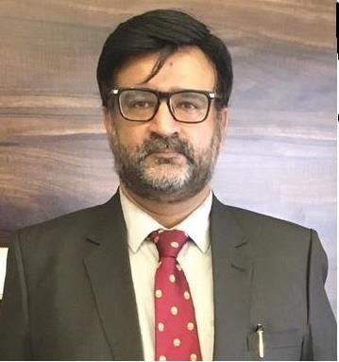
Dr. Rizwan Zeb is a Karachi based Risk and Security analyst. He is a non-resident fellow at the Center for Policy Research at the Beaconhouse National University Lahore, Pakistan. He is member of the Working group on International Measures for Compliance to Nuclear Disarmament Regimes at the Uppsala University’s Alva Myrdal Centre for Nuclear Disarmament and Associate Editor, Journal of Asian Security and International Affairs (Sage). He is a former Benjamin Meaker Professor, Institute of Advanced Studies, University of Bristol, UK and Visiting Scholar, South Asia Project, Foreign Policy Program, Brookings Institution, Washington DC, USA. He has a PhD in Political Science and International Relations from the University of Western Australia. He is the alumnus of Regional Center for Strategic Studies (RCSS) Summer workshop on Defense, Technology and Cooperative Security in South Asia and a graduate of the College of Security Studies, Daniel K. Inouye Asia – Pacific Center for Security Studies, Honolulu, Hawaii.
His area of academic interest includes South Asian Strategic Stability Issues with particular focus on Pakistan’s Security, the interface of emerging technologies and national security and Artificial intelligence and strategic stability issues.
https://orcid.org/0000-0002-1017-291X

