Gulyamov Said Saidakhrarovich  Doctor of Law, Professor | 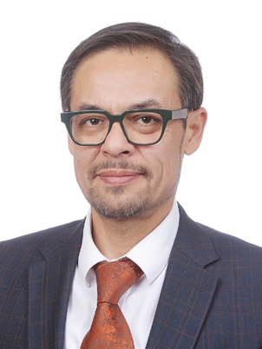
Head of the Department of Cyber Law,
Tashkent State Law University
https://gulyamov.org/
said.gulyamov1976@gmail.com
+998900018779 WhatsApp
+998983008779 Telegramm
ORCID: https://orcid.org/0000-0002-2299-2122

Prof., Dr. Said Gulyamov
Pioneer of Cyber Law & AI Ethics in Central Asia
Professor Said Gulyamov established Central Asia's first Department of Cyber Law at Tashkent State University of Law, transforming legal education through innovation. With dual DSc/PhDs in Law and Economics, he bridges Eastern and Western legal traditions, having studied at Edinburgh Napier University and leading institutions across Russia and Uzbekistan.
As architect of Uzbekistan's AI Development Strategy 2021-2030, he shapes national digital policies while maintaining global perspective through partnerships with universities in Italy, Poland, India, and Turkey. His publications in Scopus and Web of Science journals explore the intersection of law, technology, and ethics.
Beyond academia, he serves as Deputy Director at Gulyamov, Sadikov & Partners, bringing practical insights to his research. Fluent in Uzbek, Russian, and English, Professor Gulyamov mentors the next generation, having supervised 40+ DSc/PhD candidates while developing patented LegalTech solutions that democratize access to justice.

